The home page:

When a user doesn’t login and use the website as a guest:

Sign up page:

Log In Page:

The contact information page:

The about information page:

When the user login as a teacher, this is the all courses page (we haven’t create any course)

Create a new course Jave:

Course Java has been created:

Create assignments:

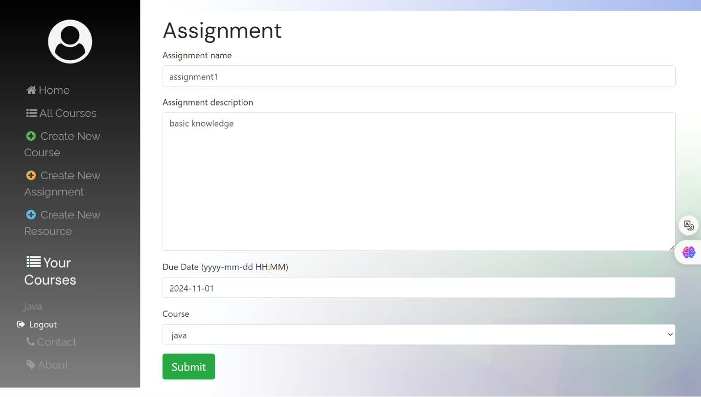

Create resources:

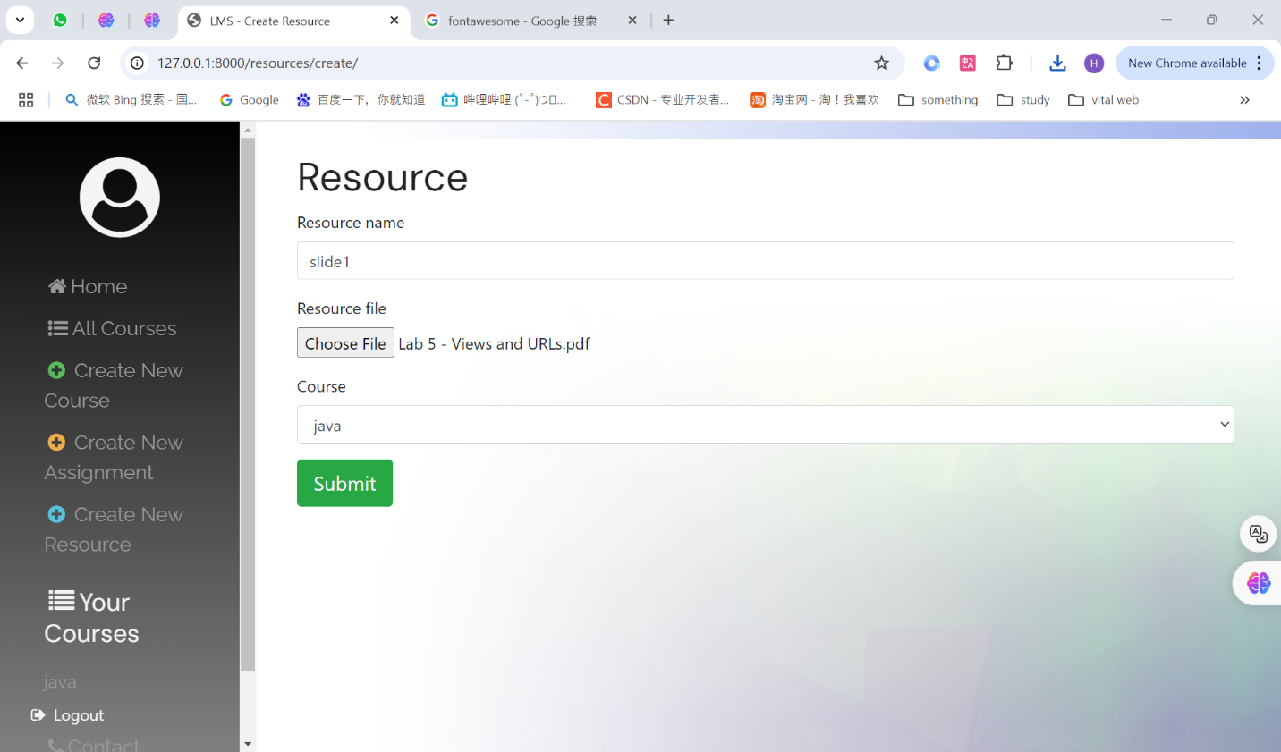

This is the course detail page after adding assignments and resources:

As a guest, they still can see the list of all courses, but they can’t see course details:

Students can choose to enroll one of the courses:

After enrollment, students can see the course details:

